1. **Agenda**:
   1. How the basic authentication flow works behind the scene.
2. 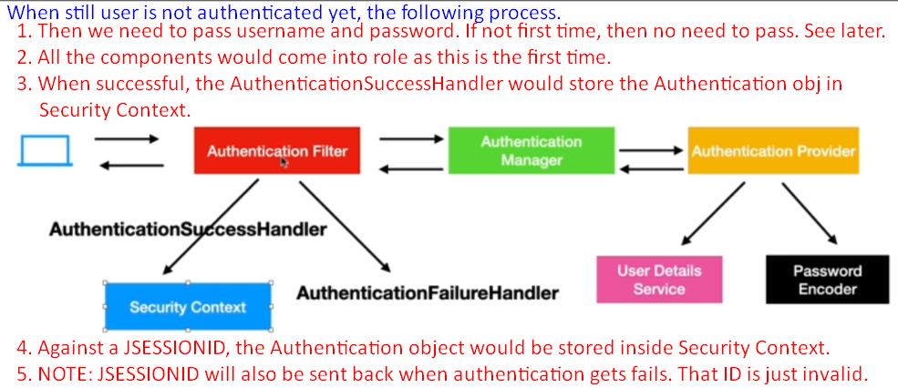
3. 